GIT ASSIGNMENT

( LEVEL1 )

NAME :Sowmya V

Creating AWS Ubantu ec2 instance.

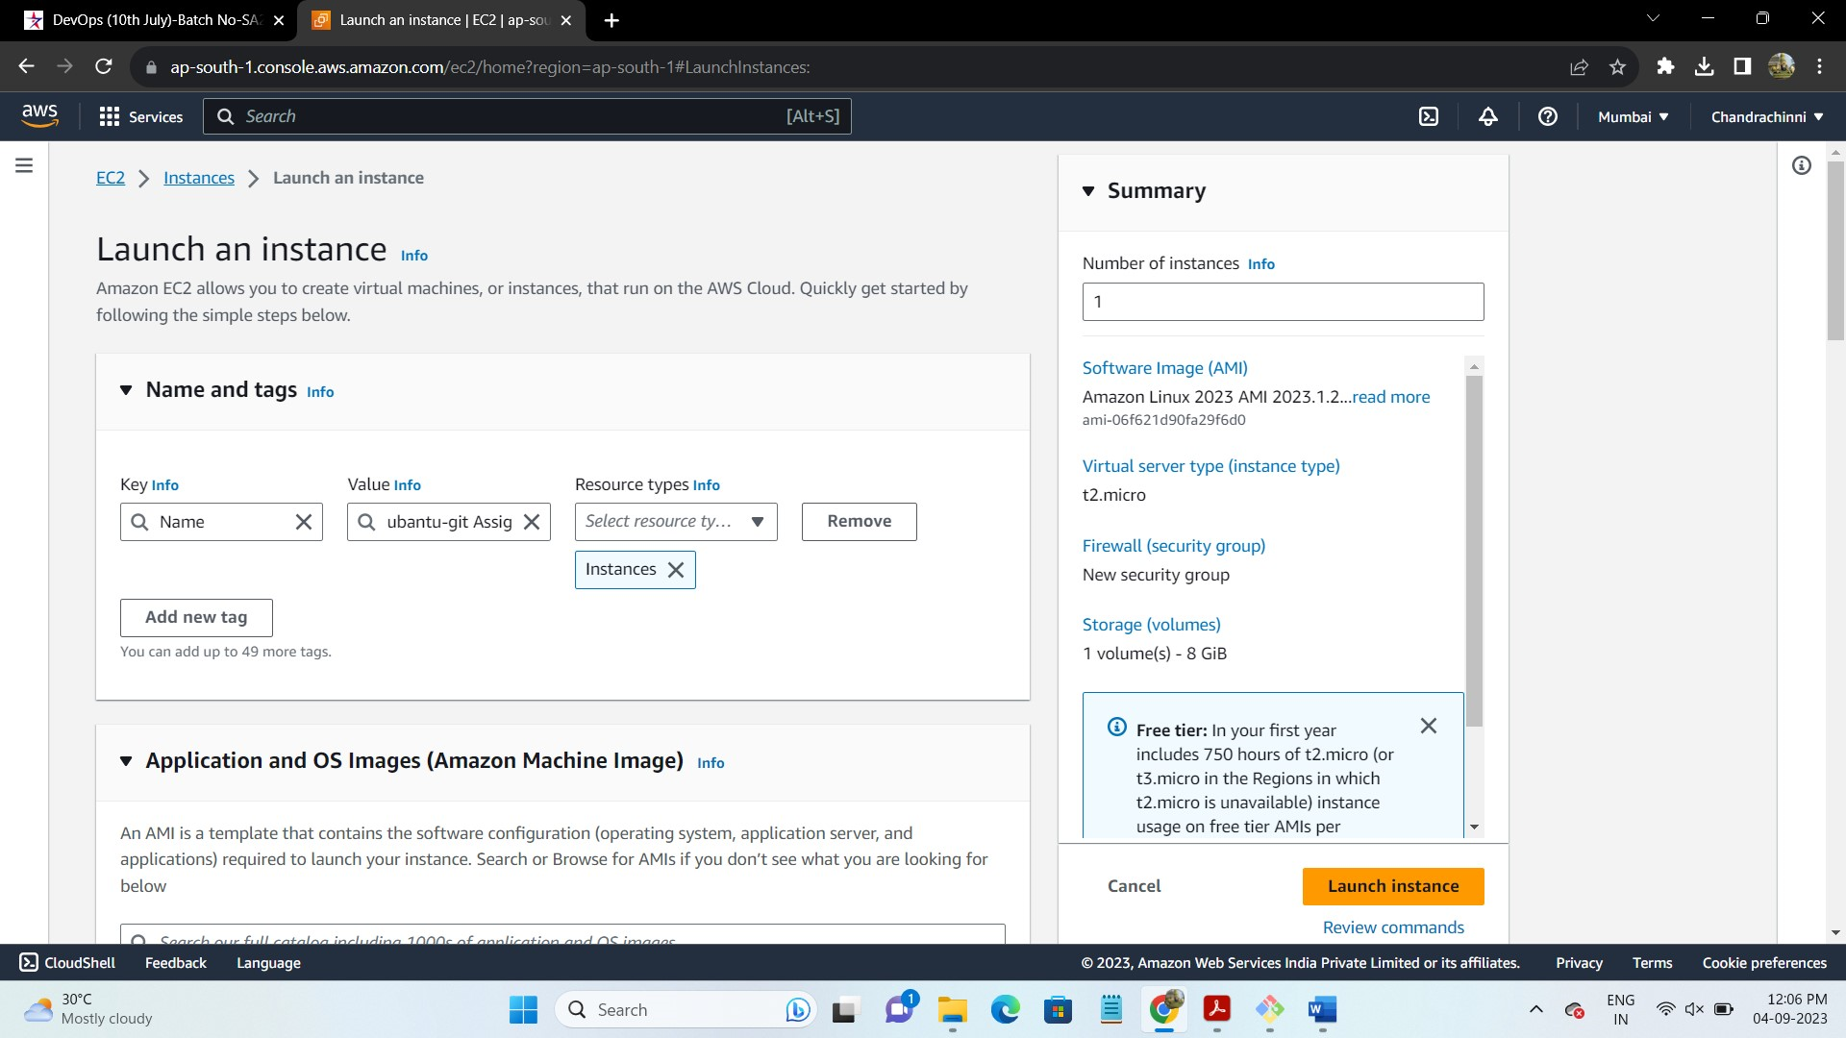

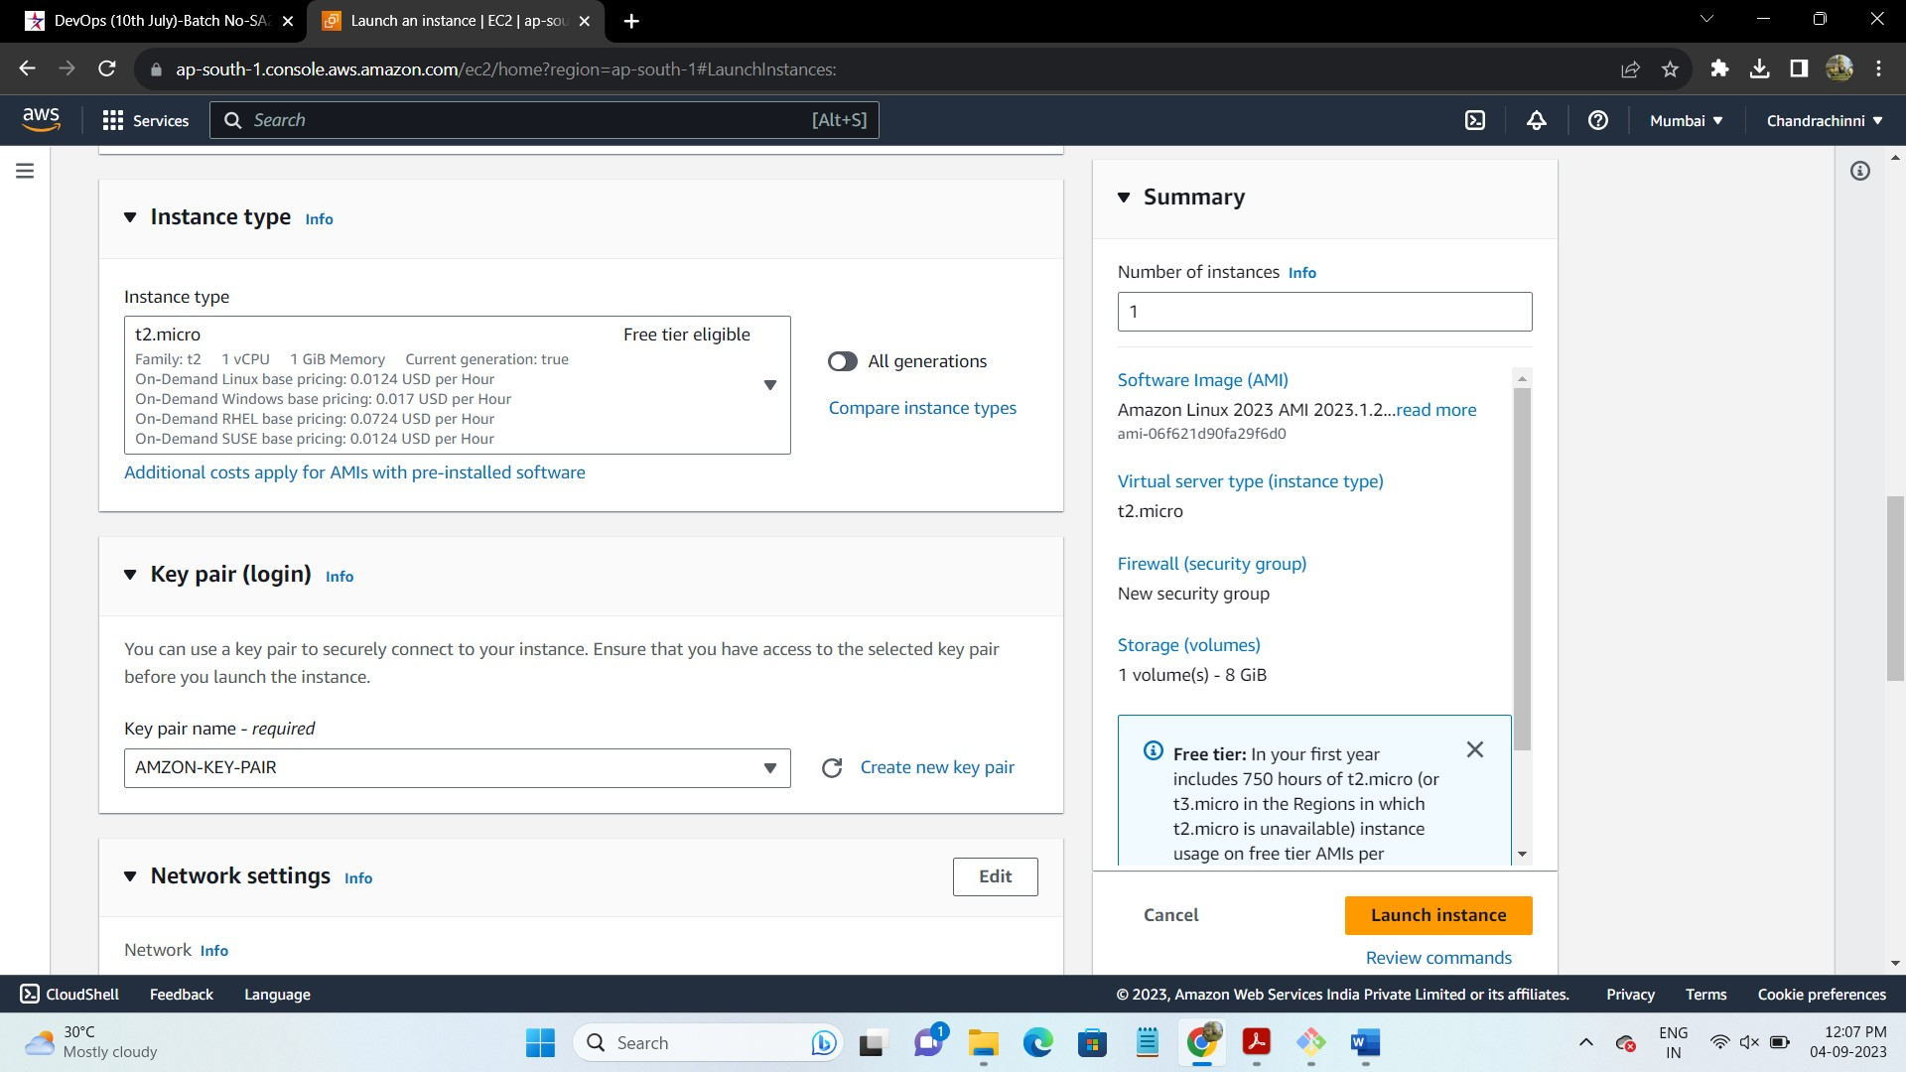

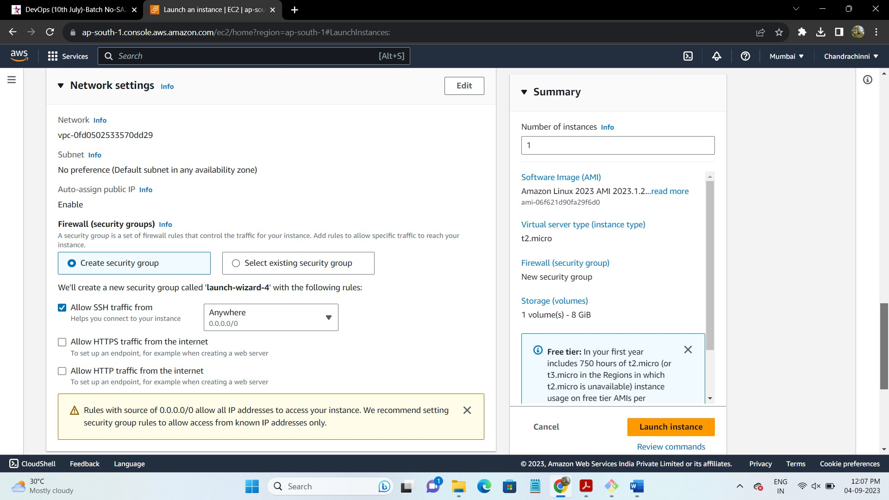

Git is already install on ubantu virtual machine

I will open the calcii project from eclipse in file explorer& upload it to my git hub it to my github repo to clone it &access so I can get the project files.

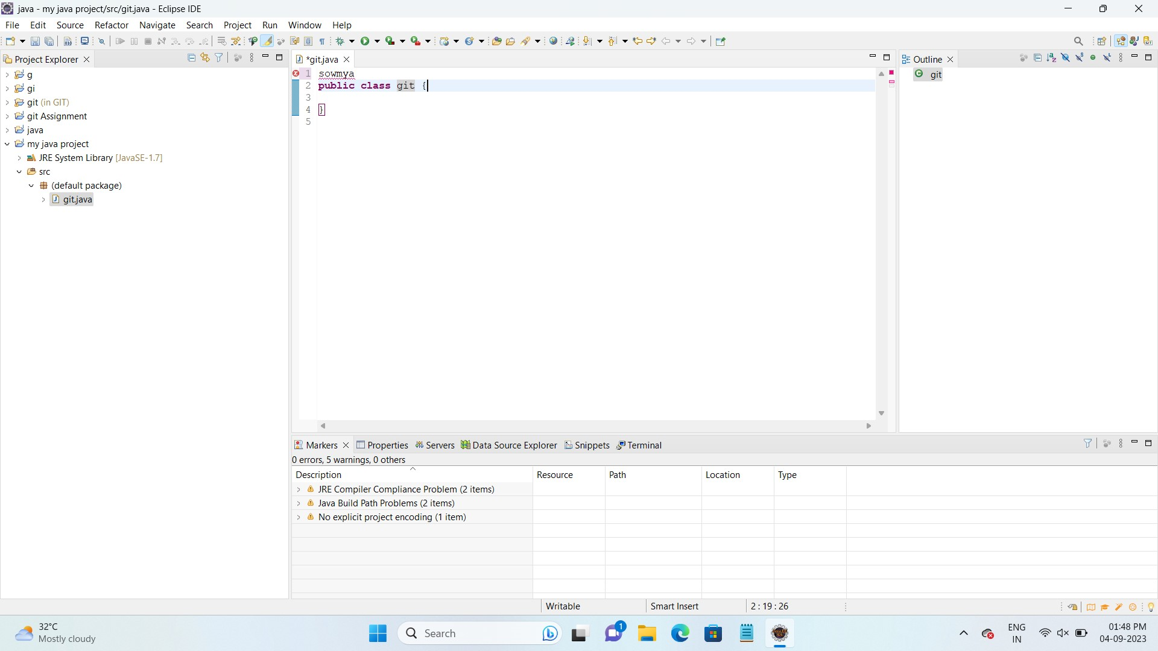

Creating a Git repository…

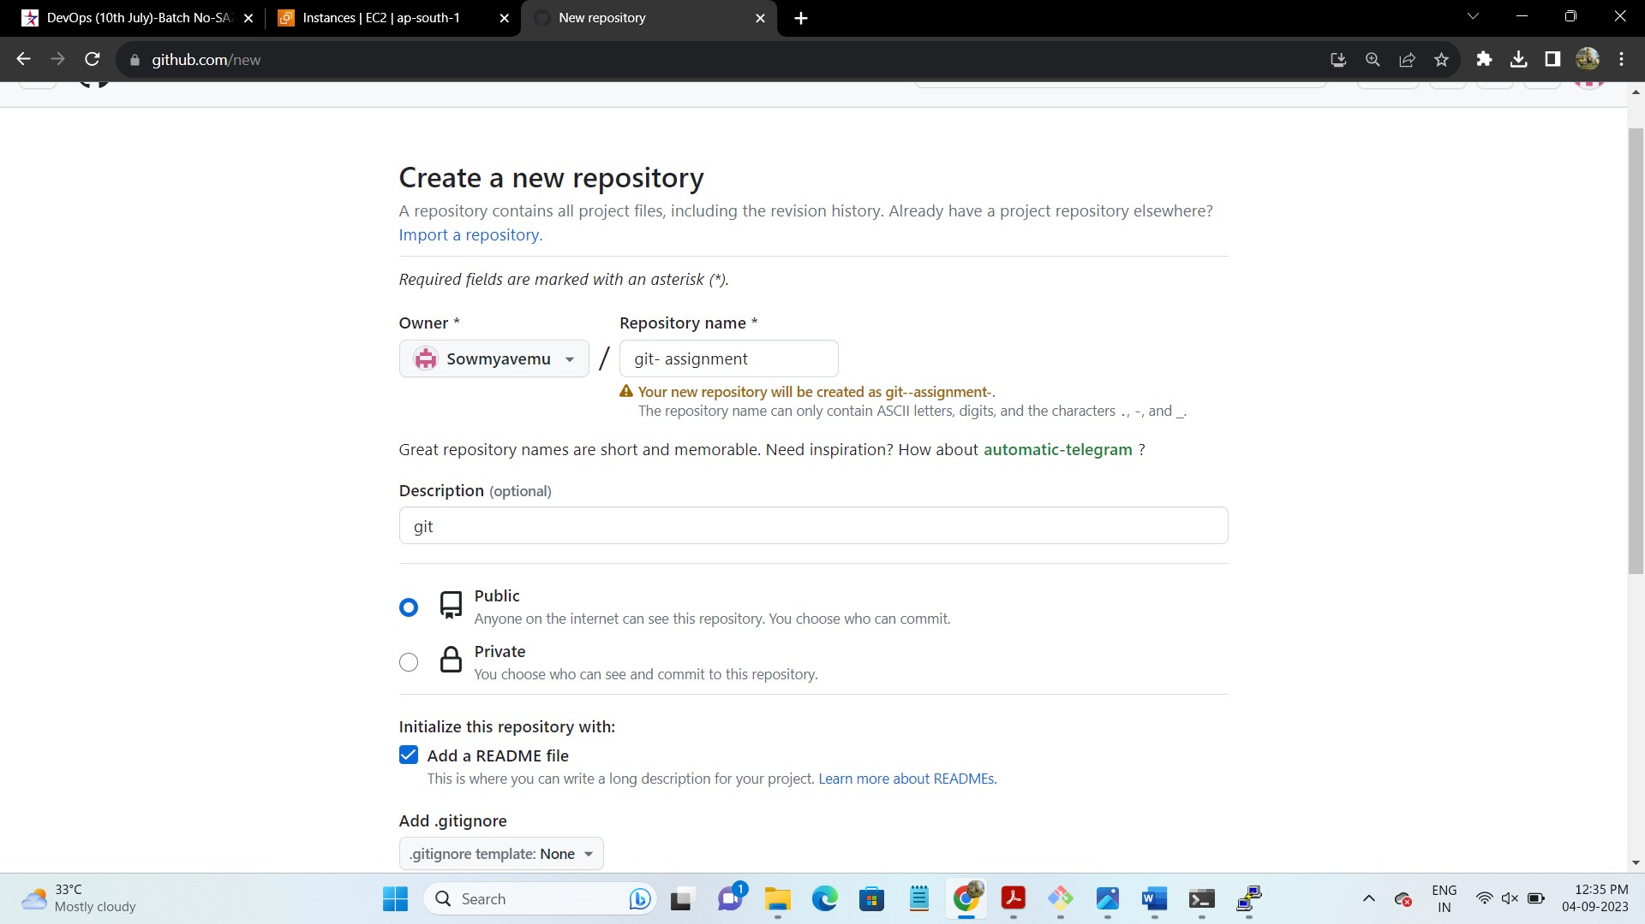

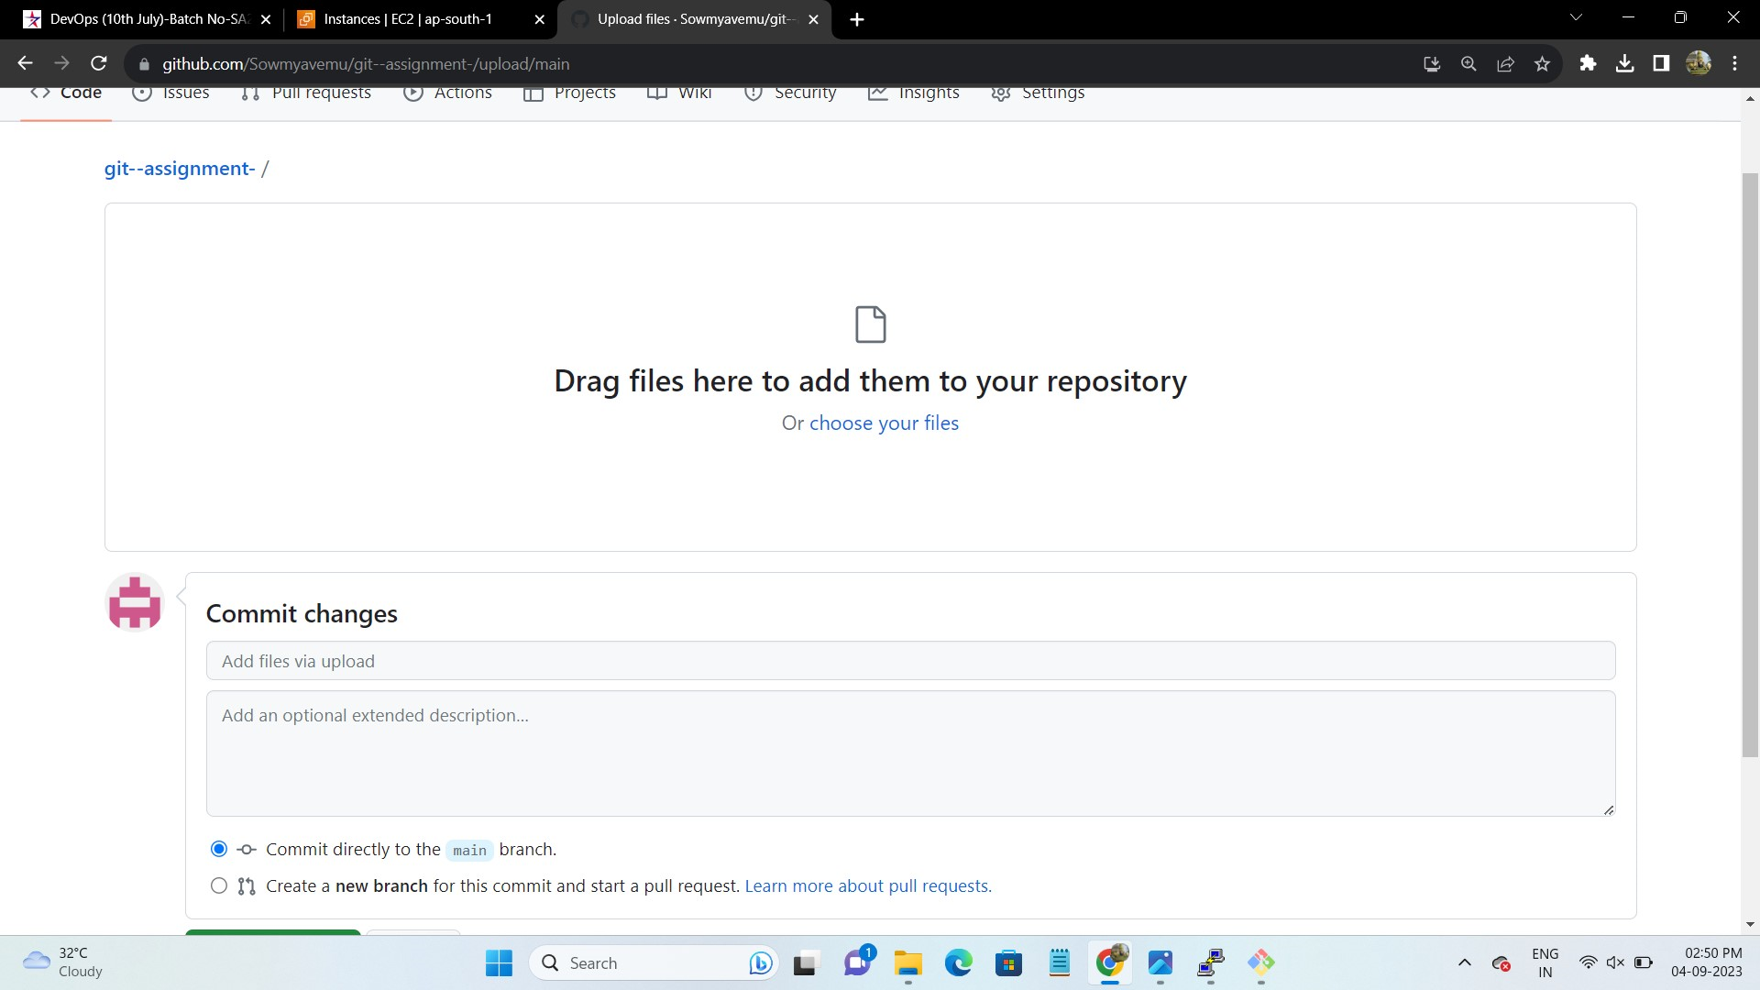

Copying the URL to clone…

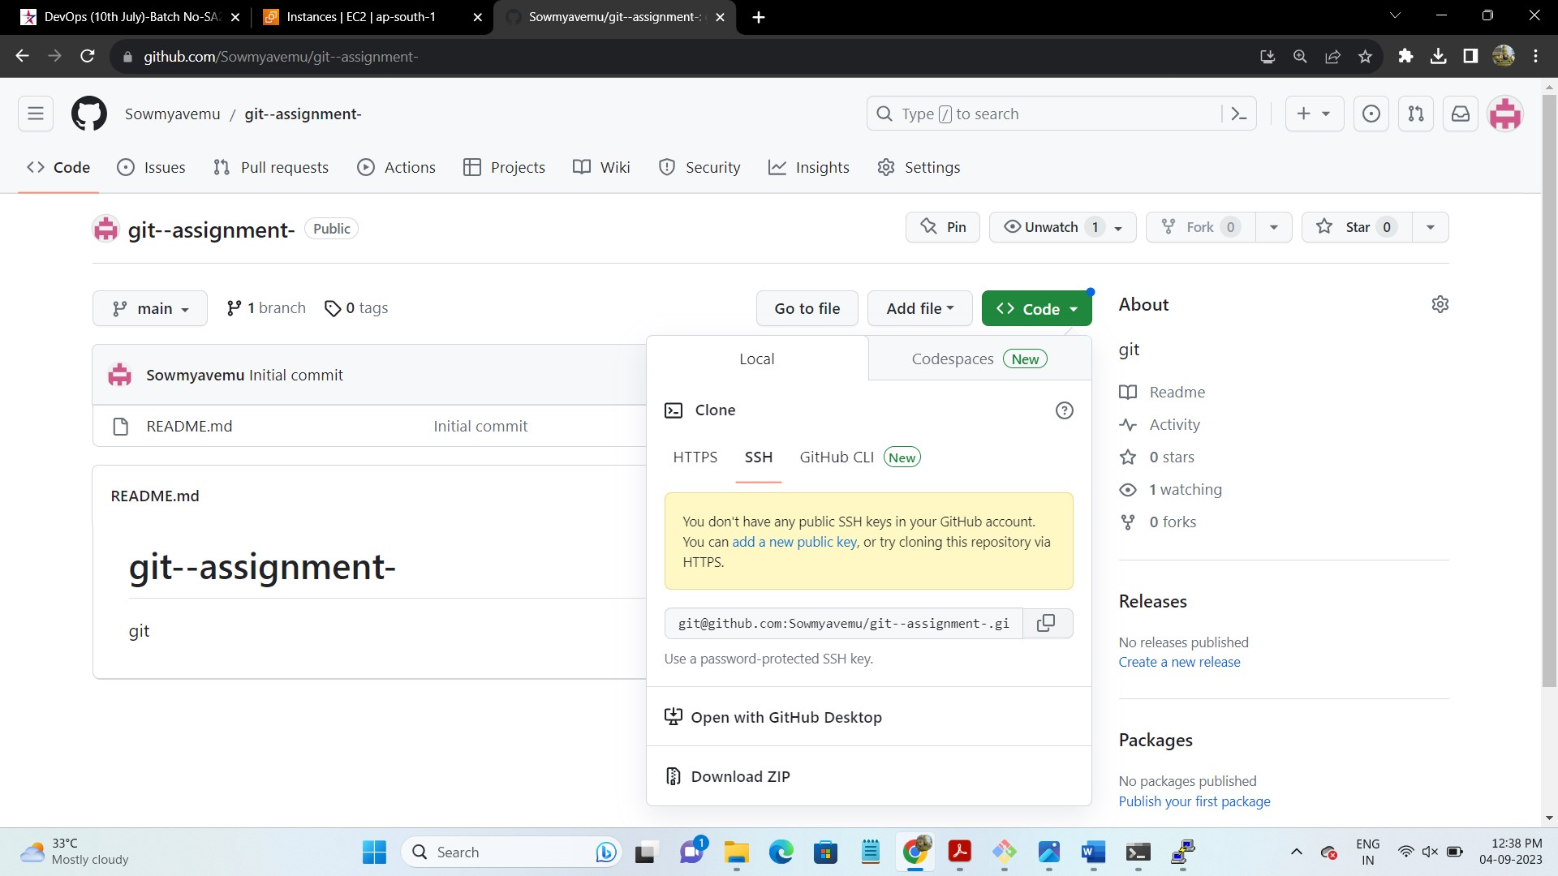

Downloaded the project zip file….